2012 – 2015 Triennium Work Report
Chapter: Definition
June 2015

Programme Committee D3: SMALL SCALE LNG
Chair: Wouter Meiring

Table of Contents²
Definition 2
Value Network 3
Conventional 4
Small Scale Whole Sale 4
Small Scale Retail 5
Small Scale Whole Sale 5
Transport 6
In the whole sale category, mainly 2 types of ship ensure the link between production/supply and offtakers : ship with tanks operated under pressure, and ship with tank operated under (almost) atmospheric pressure. 6
Regas/tank farm 6

Definitions

The LNG business started ``small’’, with the first commercial liquefaction plants since the early ‘40s being peak-shaving facilities with a capacity of around 0.002 mtpa in the US. In1964 the first base load LNG plant which started up in Arzew, Algeria (three trains with a total capacity of 1 mtpa). In 1969 by the Kenai LNG plant in Alaska (total capacity 1.5 mtpa) came online and then Marsa El Brega in Lybia (2 trains of 0.75 mtpa) shortly after.

Since then, the industry has pushed the boundaries of economy of scales for base load LNG sites, via more efficient, larger and more cost effective liquefaction trains, LNG carriers, storage and regasification plants.
While in recent years the economy of scale seems to have reached its upper limit, with the 7.8mtpa mega trains in Qatar, several reasons are bringing the attention back towards the small scale LNG (SSLNG) business: new environmental emissions policies and diverging oil and gas prices have led many regions to begin building up small-scale infrastructure. Many new regions have turned to small scale liquefaction and retail LNG in order to cut emissions and/or fuel costs. LNG is also growing in the transportation sector, both as a marine fuel and for heavy trucking, mainly in the US, Europe and China.
Producing LNG in small scale so that it can be used for transport purposes (trucks, vessels) and small industrial applications require a deep change with respect to the conventional large scale LNG chain. Supported by improvements in the technology and feasibility, the Small Scale LNG (SSLNG) business has rapidly expanded from simply being a small replica of its larger scale counterpart, consumed within the power and industrial sectors. The SSLNG business has expanded into a value network, illustrated in Figure 1, which will be described in the remainder of this section.

The report aims at providing a current picture of the SSLNG business, and is based on data coming from the SSLNG projects around the globe. Given the dynamic evolution of the business, some criteria have been selected on which projects to include in the analysis. The criteria have been capacity and maturity of the project.

The small scale LNG sector has been defined as LNG chain dealing with a capacity below 1 mtpa. For practical reason, facilities below 0.1 mtpa have not been considered in detail in this report. The reason is to avoid describing a multitude of very small projects which are flourishing in some regions of the world, for example small peak-shaving projects in China or the US, which were considered to be best captured at high level. The boundaries have been set with the objective of been inclusive in capturing all the LNG projects which surely do not belong to the conventional LNG projects.
It has to be noted, though, that the major part of the onshore SSLNG developments, involves capacities well below the 1mtpa threshold to allow the projects economics to fly.

To ensure that the list of projects taken into account would be robust, only projects which have taken FID by 2013 have been considered. This was necessary because of the large number of projects mentioned in the open literature, which might not have a solid basis, but only be a testimony of the big excitement about the possibilities that the SSLNG sector offers.

Compared to the well-established large-scale LNG industry, SSLNG is characterized by different dynamics and drivers. Therefore the production, transportation and regasification of SSLNG for new market segments such as the transportation and small industrial sectors requires the application of a variety of different technologies and commercial models to meet efficiency and cost requirements. Such differentiation is the reason why a dedicated focus is needed.

Value Network
While in the conventional base-load LNG business it was possible to talk about a ``value chain’’, mainly consisting of liquefaction plant, transport, regasification and end-user (power plant or domestic), the small-scale business is better described as a network: as shown in Figure 1, the SSLNG can be sourced by an existing conventional scale LNG element, such as the liquefaction or regasification site, or by a small scale liquefaction site itself, and can serve a wider range of end users than the conventional value chain.
The SSLNG Value network can be defined as consisting of two elements: wholesale and retail. Small-scale wholesale LNG is essentially a miniaturization of the conventional LNG value chain; gas is liquefied in small quantities, transported on a small vessel, and then imported at a small regasification plant. Retail LNG is the small-scale consumption of LNG in end-user applications, such as transport, power generation, or industrial activities. The scope of PGC-D3 is limited to the production and distribution elements of the value network up to the point where the LNG is distributed to its end users, which is referred to as Whole Sale SSLNG.
The elements provided here are a picture of a growing business, with a contour not totally defined yet. The maturity of these small scale phenomena, once established, might suggest to review/refine the boundaries of this domain.
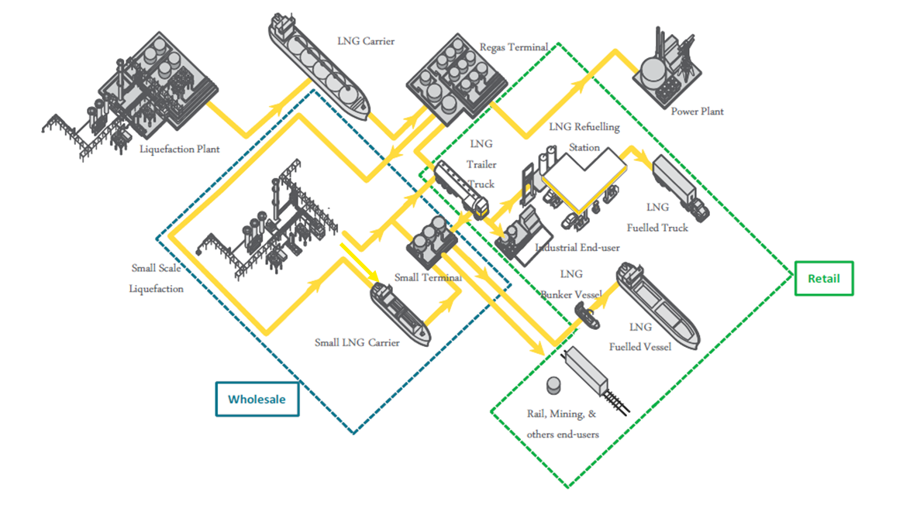
Figure 1 Small Scale LNG Value Network
Add the delivering train in the sketch on retail part.

Conventional
Conventional LNG relates to value chain generally well above 1MTPA, where LNG is a mean to transport gas from export country to importing countries, when gas pipeline appears to be a difficult solution.

Small Scale Whole Sale
Wholesale SSLNG mirrors the large scale LNG business in that it typically involves the intercontinental transport of LNG from a liquefaction plant in a producing country to a regasification plant closer to the end-user (e.g. power plants, industrial users).
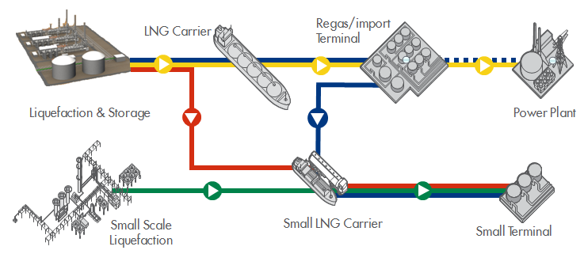
Figure 2 Five different logistic LNG distribution methods. The yellow line shows the conventional way of LNG distribution. The others represent small scale variants. Namely: the green line represents SSLNG solely, the red line represents SSLNG at liquefaction, the blue including the blue dotted line represents SSLNG at regasification and the blue without dotted blue line represents SSLNG at import terminal.

Starting from the conventional LNG supply chain, several Small Scale variants can be derived (Figure 2). For example, a Small Scale distribution can be obtained by adding a Small Scale demand source to the conventional supply chain, so for instance adding a small LNG carrier to off-take LNG volumes from either the regasification terminal (i.e. blue line and dotted blue line in Figure 2) or at the liquefaction terminal (i.e. red line in Figure 2). Currently the most examples are SSLNG at regasification terminals, as these are usually closer to the demand.
If the demand of LNG is solely coming from Small LNG Terminals, there is no regasification, and the facility receiving the LNG is called import terminal (i.e. solid blue line in Figure 2). A fourth small scale distribution method consists of only Small Scale LNG activities (i.e. green line in Figure 2). This can be for instance a small liquefaction plant that sources small scale carriers that supply regasification terminals or other downstream activities such as gas to transport.

Small Scale Retail
The retail LNG business is characterized more by an “end-user oriented” value chain. Such a value chain represents a more regional or local business that distributes and delivers smaller parcels of LNG from the liquefaction source directly to end-users, using various modes of transport (e.g. ships, trucks, semitrailers, ISO containers, or trains). The details of this portion of the SSLNG value network are relevant to the wholesale SSLN as it defines the demands in all its complexity, e.g. volumes, locations, quality, economics, etc.
Because of its complexity, the small scale retail has been looked at by the PGC-D2 group, looking at LNG as fuel. Hence, we refer to their work for further details on this topic.

Small Scale Whole Sale

Definitions here below provide specific features of the step of the value chain. For further detail refer to specific chapter.
To remain cost effective, small scale relies on modular systems and specific technologies
Production/supply
Single train capacities in small scale liquefaction plants lie typically between 0.05 and 0.5 MTPA using partly specific small scale technologies. Above 0.5 MTPA, technology relies more on conventional technologies.
However, conventional LNG terminal can act as a break bulk point of supply: this is currently what is happening in northern Europe for bunkering purposes. In that context, capacity is bounded by offtaker ship.

Transport

In the whole sale category, mainly 2 types of ship ensure the link between production/supply and offtakers : ship with tanks operated under pressure, and ship with tank operated under (almost) atmospheric pressure.
Small LNG carriers up to now range up to 30 000m3 storage volume. Usually these ships do not cross oceans and remain in a given area (no route above 2000nm). Small scale ships are less than 5% of the current global LNG fleet. So far, recent Small LNG carriers are all designed with type C tanks (under pressure).
Transport using bulk container or ISO containers, trucks, railway tank constitute another option which is not debated in this section (refer to LNG retail section).

Regas/tank farm
Regasification plant in the wholesale framework is defined so as to receive and match with the delivering ship capacity (in that respect regasification is also defined according to storage capacity). As well as ships, regas plant can be divided in two categories: those which employ conventional concept despite limited volume to be handled with a tank operated at atmospheric pressure tank, and regasification plant with pressurized LNG storage.
Implication of the pressure operating modes are described in the technology chapters further on.
Regas terminals supplied with small scale LNG ships, therefore presents sizes starting from 1000m3 capacity till 30 000m3. Practically speaking, for range of storage capacity lying between 1000 and 7000m3, regas plants with pressurized storage tanks prevail. Above 15 000m3, conventional technologies prevail.

